TEST - NON – VERBAL REASONING
- Choose the alternative which is closely resembles the mirror image of the given combination.
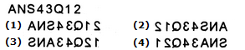
A. | 1
B. | 2
C. | 3
D. | 4

2. | Choose the alternative which is closely resembles the mirror image of the given combination.  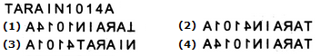
2.
  A. | 1
  B. | 2
  C. | 3
  D. | 4
3. | Choose the alternative which is closely resembles the mirror image of the given combination.  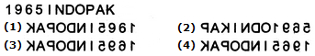
3.
  A. | 1
  B. | 2
  C. | 3
  D. | 4
4. | Choose the alternative which is closely resembles the mirror image of the given combination.  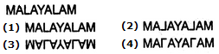
4.
  A. | 1
  B. | 2
  C. | 3
  D. | 4
5. | Choose the alternative which is closely resembles the mirror image of the given combination.  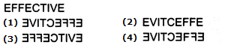
5.
  A. | 1
  B. | 2
  C. | 3
  D. | 4
6. | Choose the alternative which is closely resembles the mirror image of the given combination.  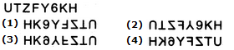
6.
  A. | 1
  B. | 2
  C. | 3
  D. | 4
7. | Choose the alternative which is closely resembles the mirror image of the given combination.  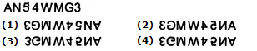
7.
  A. | 1
  B. | 2
  C. | 3
  D. | 4
. 8 | Choose the alternative which is closely resembles the mirror image of the given combination.  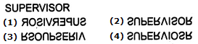
. 8
  A. | 1
  B. | 2
  C. | 3
  D. | 4
9. Choose the alternative which is closely resembles the water-image of the given combination.
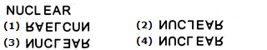
A. | 1
B. | 2
C. | 3
D. | 4

10. Choose the alternative which is closely resembles the water-image of the given combination.
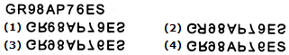
A. | 1
B. | 2
C. | 3
D. | 4

11. Choose the alternative which is closely resembles the water-image of the given combination.
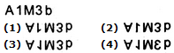
A. | 1
B. | 2
C. | 3
D. | 4

12. Choose the alternative which is closely resembles the water-image of the given combination.
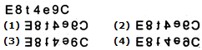
A. | 1
B. | 2
C. | 3
D. | 4

13. Choose the alternative which is closely resembles the water-image of the given combination.
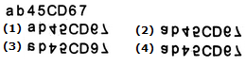
A. | 1
B. | 2
C. | 3
D. | 4

14. Choose the alternative which is closely resembles the water-image of the given combination.
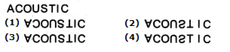
A. | 1
B. | 2
C. | 3
D. | 4

15. Choose the alternative which is closely resembles the water-image of the given combination.
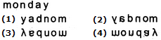
A. | 1
B. | 2
C. | 3
D. | 4

16. Choose the alternative which is closely resembles the water-image of the given combination.
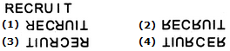
A. | 1
B. | 2
C. | 3
D. | 4

17. Choose the alternative which is closely resembles the water-image of the given combination.
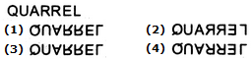
A. | 1
B. | 2
C. | 3
D. | 4

18. | Find out from amongst the four alternatives as to how the pattern would appear when the transparent sheet is folded at the dotted line.  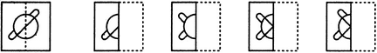  (X) (1) (2) (3) (4)
18.
  A. | 1
  B. | 2
  C. | 3
  D. | 4
19. | Find out from amongst the four alternatives as to how the pattern would appear when the transparent sheet is folded at the dotted line.  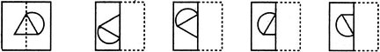  (X) (1) (2) (3) (4)
19.
  A. | 1
  B. | 2
  C. | 3
  D. | 4
20 | Find out from amongst the four alternatives as to how the pattern would appear when the transparent sheet is folded at the dotted line.  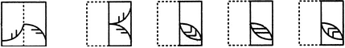  (X) (1) (2) (3) (4)
20
  A. | 1
  B. | 2
  C. | 3
  D. | 4
21 | Find out from amongst the four alternatives as to how the pattern would appear when the transparent sheet is folded at the dotted line.  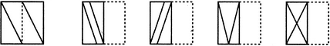  (X) (1) (2) (3) (4)
21
  A. | 1
  B. | 2
  C. | 3
  D. | 4
22 | Find out from amongst the four alternatives as to how the pattern would appear when the transparent sheet is folded at the dotted line.  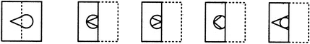  (X) (1) (2) (3) (4)
22
  A. | 1
  B. | 2
  C. | 3
  D. | 4
23 | Find out from amongst the four alternatives as to how the pattern would appear when the transparent sheet is folded at the dotted line.  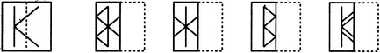  (X) (1) (2) (3) (4)
23
  A. | 1
  B. | 2
  C. | 3
  D. | 4
24 | Find out from amongst the four alternatives as to how the pattern would appear when the transparent sheet is folded at the dotted line.  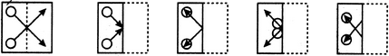  (X) (1) (2) (3) (4)
24
  A. | 1
  B. | 2
  C. | 3
  D. | 4
25 | Choose a figure which would most closely resemble the unfolded form of Figure (Z).  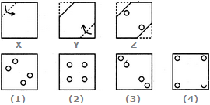
25
  A. | 1
  B. | 2
  C. | 3
  D. | 4
26 | Choose a figure which would most closely resemble the unfolded form of Figure (Z).  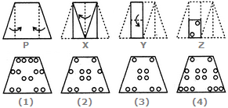
26
  A. | 1
  B. | 2
  C. | 3
  D. | 4
27 | Choose a figure which would most closely resemble the unfolded form of Figure (Z).  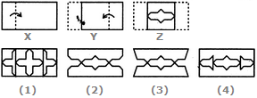
27
  A. | 1
  B. | 2
  C. | 3
  D. | 4
28 | Choose a figure which would most closely resemble the unfolded form of Figure (Z).  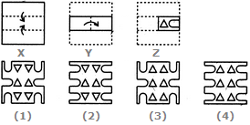
28
  A. | 1
  B. | 2
  C. | 3
  D. | 4
29 | Choose a figure which would most closely resemble the unfolded form of Figure (Z).  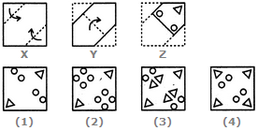
29
  A. | 1
  B. | 2
  C. | 3
  D. | 4
29 | 30. Choose a figure which would most closely resemble the unfolded form of Figure (Z).  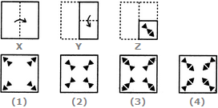
29
  A. | 1
  B. | 2
  C. | 3
  D. | 4
31 | Choose a figure which would most closely resemble the unfolded form of Figure (Z).  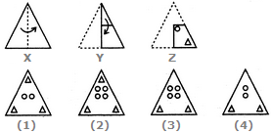
31
  A. | 1
  B. | 2
  C. | 3
  D. | 4
32 | Choose a figure which would most closely resemble the unfolded form of Figure (Z).  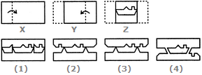
32
  A. | 1
  B. | 2
  C. | 3
  D. | 4
33 | Find out the alternative figure which contains figure (X) as its part.  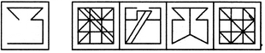  (X) (1) (2) (3) (4)
33
  A. | 1
  B. | 2
  C. | 3
  D. | 4
34 | Find out the alternative figure which contains figure (X) as its part.  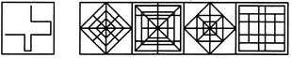  (X) (1) (2) (3) (4)
34
  A. | 1
  B. | 2
  C. | 3
  D. | 4
35 | Find out the alternative figure which contains figure (X) as its part.  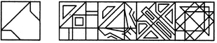  (X) (1) (2) (3) (4)
35
  A. | 1
  B. | 2
  C. | 3
  D. | 4
36 | Find out the alternative figure which contains figure (X) as its part.  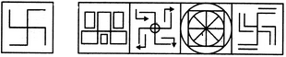  (X) (1) (2) (3) (4)
36
  A. | 1
  B. | 2
  C. | 3
  D. | 4
37 | Find out the alternative figure which contains figure (X) as its part.  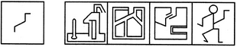  (X) (1) (2) (3) (4)
37
  A. | 1
  B. | 2
  C. | 3
  D. | 4
38 | Find out the alternative figure which contains figure (X) as its part.  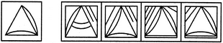  (X) (1) (2) (3) (4)
38
  A. | 1
  B. | 2
  C. | 3
  D. | 4
39 | Find out the alternative figure which contains figure (X) as its part.  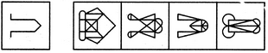  (X) (1) (2) (3) (4)
39
  A. | 1
  B. | 2
  C. | 3
  D. | 4
40 | Find out the alternative figure which contains figure (X) as its part.  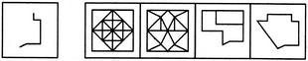  (X) (1) (2) (3) (4)
40
  A. | 1
  B. | 2
  C. | 3
  D. | 4
41 | Choose the figure which is different from the rest.  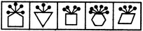  (1) (2) (3) (4) (5)
41
  A. | 1
  B. | 2
  C. | 3
  D. | 4
  E. | 5
42 | Choose the figure which is different from the rest.  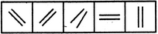  (1) (2) (3) (4) (5)
42
  A. | 1
  B. | 2
  C. | 3
  D. | 4
  E. | 5
43 | Choose the figure which is different from the rest.  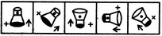  (1) (2) (3) (4) (5)
43
  A. | 1
  B. | 2
  C. | 3
  D. | 4
  E. | 5
44 | Choose the figure which is different from the rest.  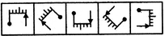  (1) (2) (3) (4) (5)
44
  A. | 1
  B. | 2
  C. | 3
  D. | 4
  E. | 5
45 | Choose the figure which is different from the rest.  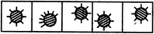  (1) (2) (3) (4) (5)
45
  A. | 1
  B. | 2
  C. | 3
  D. | 4
  E. | 5
46 | Select a suitable figure from the Answer Figures that would replace the question mark (?).  Problem Figures: Answer Figures:  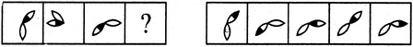  (A) (B) (C) (D) (1) (2) (3) (4) (5)
46
  A. | 1
  B. | 2
  C. | 3
  D. | 4
  E. | 5
47 | Select a suitable figure from the Answer Figures that would replace the question mark (?).  Problem Figures: Answer Figures:  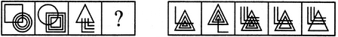  (A) (B) (C) (D) (1) (2) (3) (4) (5)
47
  A. | 1
  B. | 2
  C. | 3
  D. | 4
  E. | 5
48 | Select a suitable figure from the Answer Figures that would replace the question mark (?).  Problem Figures: Answer Figures:  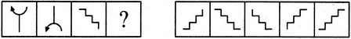  (A) (B) (C) (D) (1) (2) (3) (4) (5)
48
  A. | 1
  B. | 2
  C. | 3
  D. | 4
  E. | 5
49 | Select a suitable figure from the Answer Figures that would replace the question mark (?).  Problem Figures: Answer Figures:  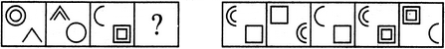  (A) (B) (C) (D) (1) (2) (3) (4) (5)
49
  A. | 1
  B. | 2
  C. | 3
  D. | 4
  E. | 5
50 | Select a suitable figure from the Answer Figures that would replace the question mark (?).  Problem Figures: Answer Figures:  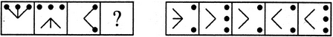  (A) (B) (C) (D) (1) (2) (3) (4) (5)
50
  A. | 1
  B. | 2
  C. | 3
  D. | 4
  E. | 5
51 | Identify the figure that completes the pattern.  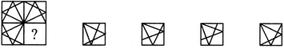  (X) (1) (2) (3) (4)
51
  A. | 1
  B. | 2
  C. | 3
  D. | 4
52 | Identify the figure that completes the pattern.  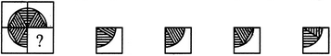  (X) (1) (2) (3) (4)
52
  A. | 1
  B. | 2
  C. | 3
  D. | 4
53 | Identify the figure that completes the pattern.  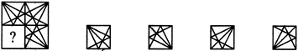  (X) (1) (2) (3) (4)
53
  A. | 1
  B. | 2
  C. | 3
  D. | 4
54 | Identify the figure that completes the pattern.  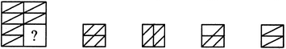  (X) (1) (2) (3) (4)
54
  A. | 1
  B. | 2
  C. | 3
  D. | 4
55. | Identify the figure that completes the pattern.  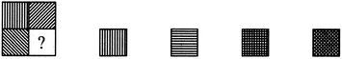  (X) (1) (2) (3) (4)
55.
  A. | 1
  B. | 2
  C. | 3
  D. | 4

Answers
- B
- D
- D
- B
- A
- D
- B
- A
- D
- C
- C
- D
- B
- B
- D
- B
- A
- D
- C
- D
- D
- A
- C
- B
- C
- C
- B
- B
- B
- C
- C
- C
- A
- D
- D
- C
- D
- D
- B
- D
- A
- C
- D
- A
- B
- C
- A
- A
- B
- C
- D
- C
- D
- D
- B

